Feedback Plan
Purpose:
Evaluate the performance and user compliance .Different users percieve, understand and take in information differently, technical users analyse code and security, non-technical users judge visual branding and ease of use.

Audience segmentation:
Group: Technical
Names: Bob, Humza, James
Roles: Senior Dev, QA, DevOps
Focuses:security(GDPR), database integrity, api robustness, modularity, code legibility

Group:Non-Technical
Names: suraj, josh, jeff
Role: Farm owner, student, teacher
Focuses:Layout, Navigation, trust, visuals, ux

Method evaluation:

Method: Screen walkthrough
Tool: OBS
Evaluation: Large files
Future:Compressed mp4

Method: Questionare
Tool: Microsoft forms
evaluation:inefficient for large list of questions per tester. lacks automated analysation.
Future: i would use surveymonkey
Method: Think aloud test
Tool: audio recorder
critique: Transcription was time consuming
Future: automated transcription

Demonstration Materials:
Demo: layout
File: GLH_Layout_demo.mp4
Duration: 9 min
what ir proves: all pages navigate to login to signup to home to filters to details to cart to checout to history to producer to admin to profile to accessibility
Demo: Responsiveness
File: GLH_Responsiveness_Demo.mp4
Duration: 5min
what it proves: css Grid minmax(220px, 1fr) adapts 1920px to 375

Demo: Accessibility
File: GLH_Accessibility_Demo.mp4
Duration:4 min
what it proves:light/dark mode, large text, reduced motion, tab-key navigation. WCAG 2.1 Level AA

Demo: Backend/DB
File: GLH_Backend_Demo.mp4
duration: 5 min
what it proves: users.json updates live: registration to aplication to aproval to product-add to checout. prototype only

Demo: API integrity
File GLH_API_Integrity_Demo.mp4
Duration: 5min
what it proves: invalid login regected, rate limit 429, admin route 403, insufficient stock 400,Postman tests:XSS sanitized

detailed surveys and data analysis

technical survey 104 questions (bob, humza, james)

category: code legibility
Questions: 1 – 24
agreement percentage: 78%
key tester evaluation:Humza (q12): “variable names like x inline styles should be btnStyle. Would not share with a buisness professional as-is.”

category: security/GDPR
questions 25 – 52
agreement percentage: 92%
Key tester evaluation: James (q28): “100% of testers idenntified JWT in localStorage as a production XSS risk. httpOnly cookies required.”

category: database integrity
questions: 53-78
agreement Percentage: 88%
key tester evaluation:bob(q88): “global error handle returns identical message for all 500s. makes production debugging imposible.”

non-technical survey 73 questions (suraj, josh, jeff)
category: first impressions
question:1 - 12
positive percentage: 68%
key negative point: jeff(q3): “No image avalible looks unprofessional for a real shop.”

category browsing
questions: 13 – 28
positive percentage 75%
key negative point: josh(q34): “checkout form is long and intimidating just want apple pay.”

category producer features
questions: 45 – 58
positive percentage: 48%
key negative point: suraj (q51): “would never know i could sell here. ‘apply to producer’ button is hidden. needs a homepage banner.”
category: accessibility
questions 59 – 68
positive precentage: 85%
key negative point:jeff (q62): “large text is still too small. need a super size option.”

category: trust
questions: 69 – 73
positive percentage: 58%
key negative points: josh (q 71): “need padlock and secure checout badge befor entering real card.”

record of feedback

complete feedback log

feature | tester | feedback | opinion | Severity
database | bob | “JSON storage causes race conditions. Migrate to MongoDB/PostgreSQL.” | Negative | critical
security | james | “JWT in local storage = XSS risk. Use httpOnly cookies.” | Negative | critical
Checkout | Humza | “stock check and write not atomic. overselling possible” | Negative | critical
testing | Bob | “zero test coverate. Add Jest+ supertest+ Playwright.” | Negative | High
Navigation | Humza | “window.location.reload() defeats SPA purpose use react router.” | negative | Medium
Sanitize | James | “sanitize strips script tags but should also strip onekick for dom xxs.” | Negative | Medium
Accessibility | Bob | “aria labels and keyboard nav are well implemented | Positive | Low
Middleware | Humza | “zod validation + middlewate chain is clean and maintainable.” | Positive | low
Homepage | Jeff | “too bland. initial impression was boring and unwelcoming.” | Negative | High
Images | Suraj | “missing product images makes the site look unfinished.” | Negative | Medium
Checkout ux | Josh | “form has tooomany fields. no saved adress or payment options.” | Negative | High
Producer cta | Suraj | “cannot find wher to apply as seller . buried in account page.” | Negative | High
Large text | Jeff | “even larger text mode is too small for my eyes.” | Negative | Medium
Trust badges | Josh | “no SSL padlock visible. no secure checkout badge.” | Negative | Medium
Category filters | Josh | “filtering works well and is intuitive.” | Positive | Low
Cart | Suraj | “adding and removing items is straight forward.” | Positive | low
Loyalty points | Jeff | “earning points is a nive incentive to return.” | Positive | Low
Light mode | Suraj | “light mode option is helpful for daytime use.” | Positive | low

summary statistics
total items: 18
positive:16
negative:11
neutral:1

critical :3
high: 5
medium: 7
low: 3

legal, security, and ethical compliance

GDPR compliance

data transparecy: users must accept terms and conditions befor registering
data minimisation: only name, email and hashed password are collected. no payment card data is stored
right to erasure: not yet implemented, identified as future requirement.
consent: explicit consent obtained for feedback sessions via signed consent forms

WCAG compliance

font resizing: accessibility panel offers large text mode(confirmed functional in the demo)
colour contrast dark theme uses #19106d/#03011d background with #fff text(contrast ratio greater than 7:1) light mode toggles to #f5f5f5 with #000 text
keyboard navigation: full tab-key operability , skip to content link, focus indicators
screen reader: aria lables, aria-live refions for dynamic content, role=”alert” for errors
audit status: manual testing confirmed, automatic lighthouse audit not yet run-added to future tasks.

content | source | Type of content | Purpose | date | Licence type
 | https://alyvewellness.com/blogs/nutrition/an-apple-a-day-keeps-the-doctor-away-right |  |  |  | All rights reserved
 | https://www.theargus.co.uk/news/25628533.british-winter-strawberries-grown-chichester-farm/ |  |  |  | All rights reserved
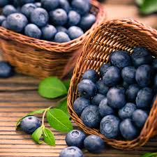 | https://www.amazon.co.uk/Bakoki%C2%AE-Premium-Organic-Blueberry-Fruits/dp/B08HRPR9F7 |  |  |  | All rights reserved
 | https://www.jamiesonbrothers.com/jamieson-brothersr-carrot-early-nantes-ii-vegetable-seeds-approx-5000-seeds |  |  |  | All rights reserved
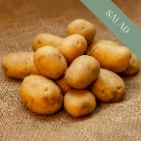 | https://premierseedsdirect.com/product/potato-seeds-charlotte/ |  |  |  | All rights reserved
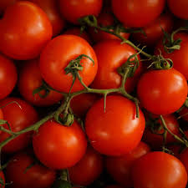 | https://mollyspantry.co.uk/products/cherry-vine-toms-300g |  |  |  | All rights reserved
 | https://www.brandeastfortune.co.uk/product/spinach |  |  |  | All rights reserved
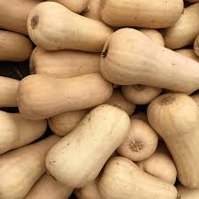 | Squash Honey Butternut - Salt Spring Seeds – Wildwood Outdoor Living |  |  |  | All rights reserved
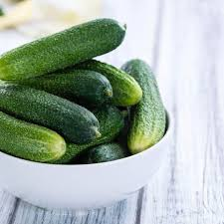 | https://www.amazon.co.uk/Vegetable-Plants-Cucumber-Petita-Full/dp/B09B6FJNVD |  |  |  | All rights reserved
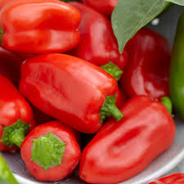 | https://www.gardeningexpress.co.uk/traditional-sweet-pepper-collection-pack-of-six-plants-21813 |  |  |  | All rights reserved
 | https://www.thescottishsun.co.uk/news/16099780/tesco-banana-order-double-island-population/ |  |  |  | All rights reserved
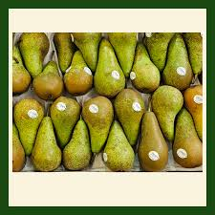 | https://thefruitbowl.uk/product/farm-fresh-conference-pears-naturally-sweet/ |  |  |  | All rights reserved
 | https://www.diy.com/departments/herb-garden-mint-1-litre-potted-plant-x-1/5057554187751_BQ.prd
 | https://theonlinegreengrocer.com/products/parsley |  |  |  | All rights reserved
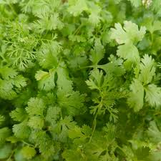 | https://seedmegastore.co.uk/herb-coriander-calypso/ |  |  |  | All rights reserved
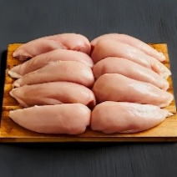 | https://www.meatsupermarket.com/products/chicken-breast-2kg |  |  |  | All rights reserved
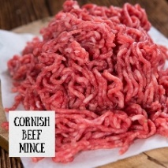 | https://www.thecornishfoodboxcompany.co.uk/beef-mince-1kg.html |  |  |  | All rights reserved
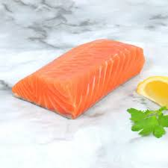 | https://thecornishfishmonger.co.uk/products/royal-fillet-of-salmon |  |  |  | All rights reserved
 | https://www.thecornishfoodboxcompany.co.uk/cornish-cod-fillet-300g.html |  |  |  | All rights reserved
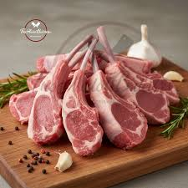 | https://thehalalbutchers.co/product/lamb-chops/ |  |  |  | All rights reserved
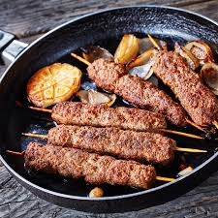 | https://www.aussiemeat.hk/blogs/recipes-feed/how-to-prepare-lamb-kofta |  |  |  | All rights reserved
 | https://x.com/paakittadnya/status/2033806228720390536 |  |  |  | All rights reserved
 | https://www.amazon.co.uk/Free-Range-Whole-Chicken-1-8kg/dp/B0B8B6KH7X |  |  |  | All rights reserved
 | https://www.amazon.co.uk/Pepperoni-Expertly-Crafted-Flavours-Charcuterie/dp/B0CHK212TK |  |  |  | All rights reserved
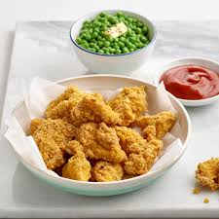 | https://www.freee-foods.co.uk/recipes/gluten-free-chicken-nuggets/ |  |  |  | all rights reserved
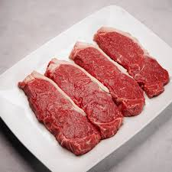 | https://www.meatsupermarket.com/products/sirloin-steak-4x-8oz |  |  |  | all rights reserved
 | https://www.heathrilesbbq.com/blogs/favorite-recipes/how-to-cook-glazed-chicken-wings-on-the-weber-kettle-grill |  |  |  | All rights reserved
 | https://www.charlesfrazer.co.uk/shop/turkey-breast-mince/ |  |  |  | All rights reserved
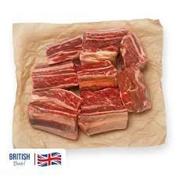 | https://www.meatsupermarket.com/products/1-3-1-7kg-short-beef-ribs |  |  |  | All rights reserved
 | https://www.ubereats.com/gb/store/idyn-pizza/zz7qAFVJWBO9sh1LFpc3Ow |  |  |  | All rights reserved
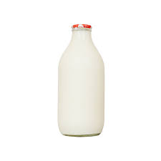 | https://www.milkandmore.co.uk/Fresh-Milk-Delivery/Channel-Island-Milk/Channel-Island-Gold-Foil-Fresh-Unhomogenised-Milk-in-Glass,-568ml,-1pt/p/2003511 |  |  |  | All rights reserved
 | https://www.nealsyarddairy.co.uk/products/the-cheddar-selection |  |  |  | All rights reserved
 | https://northumbrianeggs.com/products/tray |  |  |  | All rights reserved
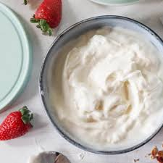 | https://www.amazon.co.uk/Premium-Yoghurt-Turkish-Strained-Container/dp/B0DR7KKP4W |  |  |  | All rights reserved
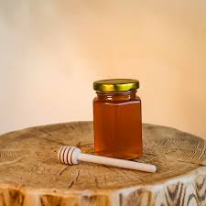 | https://savortherise.com/products/local-iowa-honey |  |  |  | All rights reserved
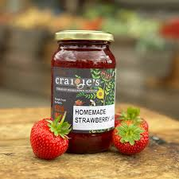 | https://craigies.co.uk/product/craigies-strawberry-jam-440g/ |  |  |  | All rights reserved
 | https://www.shopevoo.com/blogs/appetizers/fresh-baked-focaccia-with-garlic-olive-oil-sea-salt |  |  |  | All rights reserved
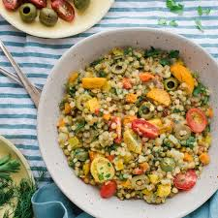 | https://instantpot.co.uk/israeli-couscous-and-lentils/ |  |  |  | All rights reserved
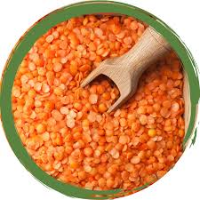 | https://www.alibaba.com/showroom/red-lentils-whole-canada-whole-red-lentils-canada.html |  |  |  | All rights reserved
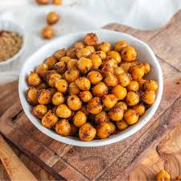 | https://groceries.morrisons.com/recipes/air-fryer-roasted-chickpeas/71V9LxL8gk9dMp3Z8zrKfm |  |  |  | All rights reserved
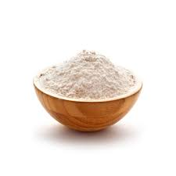 | https://www.chemistrystore.com/Soap_Making_Supplies-Cream_of_Tartar_Pot_Bitartrate.html |  |  |  | All rights reserved
 | https://vicofoodbox.com/en/caputo-flour-essential-for-the-perfect-pizza-and-more.htm |  |  |  | All rights reserved
 | https://www.noblefoods.ae/services/sunflower-oil/ |  |  |  | All rights reserved
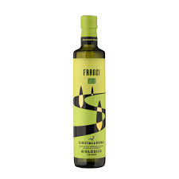 | https://www.artisanoliveoilcompany.co.uk/products/franci-bio-organic-extra-virgin-olive-oil?variant=55597473988986 |  |  |  | All rights reserved

ASSET | Source | License | Compliance
React framework | Meta / npm | MIT License | Open source
Vite build tool | Vite Team | MIT License | Open source
Express.js | Vite Team | MIT License | Open source
Bootstrap | Not used | N/A | Pure CSS3 used instead
API data | Internal JSON database | Original | No ecternal API dependency

security measures:
passwords hashed with bycrypt
JWT signed with environment secret, 1 hour expiry
rate limiting: 300 req/15 min global, 30req/15min autg
helmet security headers, CORS restricted, Xpowered-by disabled
input sanitization strips HTML tags (XSS prevention)
Zod schema validation prevents malformed data

evaluation and future planning
KPI linkage
KPI | Evidence | Status
Secure checkout | Humza confirmed visa validation blocks bad cards | PASS
Role based access controll | Admin routes return 403 for non-admin users | PASS
Input sanitization | XSS payload script alert(1) stripped | PASS
Responsive design | Resizes correctly 1920px to 375 | PASS
Accessibility (WCAG AA) | Large text, keyboard navigation, aria lavels functional | PASS
Producer onboarding clarity | Suraj could not find “apply” button | FAIL
Checout conversion | Joash found form”intimidating” | PARTIAL
Visual brand appeal | Jeff called it “bland” | FAIL
Production database readiness | 100% of technical testers rejected JSON file | FAIL
Test coverage | Zero automated tests exist | FAIL

Microsoft forms: it allowed easy distribution to 6 testers, analysing 104 technical questions times 3 testers manually was inefficient and error prone, it lacked automated analysation, sentiment analysation and branched logic. in the future i will use surveymonkey or build a custom sql-backed survey dashboard to generate auto kpi reports and visualise response distributions instantly

OBS studio: produced high quality screen recordings but generated 500mb+ files, in the future i should use lower buitrate or builtin browser recording apis

GLH version 2.0

Priority | Improvement | Source Feedback | Technical Detail
Critical | Migrate to MongoDB/PostgreSQL | Bob:”json causes race conditions” | Add Mongoose ORM, connection pooling, atomic transaction for checkout
Critical | httpOnly cookie authentication | James: “JWT in local storage = XSS risk” | Replace localstorage.setitem(“token”) with res.cookie (“token”,...,{httpOnly: true, secure:true})
Critical | Atomic checkout transaction | Humza:”stock check and write not atomic” | Implement pessimistic locking or MongoDB transactions around stock validation and decrement
High | Add comprehensive test suite | Bob: “zero test coverage” | Jest for unit tests, supertests for api integration tests, playwright for R2R checkout journey
High | Simplify checjout + saved adresses | Josh “form is intimidating” | Add adress book,apple pay/paypal, one click checkout for returning users
High | “sell with us” homepage CTA | Suraj”apply button is hidden” | Add prominent banner above product grid with href=”#profile”
High | Vibrant visual rebrand | Jeff: “too bland and boring” | Add hero image carousel, brighter accent colours (#ff6b6b, #ffd93d) animated transitions
Medium | Super-scale accessibility | Jeff: “large text still too small” | Add 200% zoom mode (font-size: 2rem base) and audio narrator for product descriptions
Medium | Trustbadges on checkout | Josh: “need padlock badge” | Add norton.McAfee-style badge row, SSL indicator, “pci compliant” footer
Medium | Image upload for producers | Suraj:”missing images look unprofessional” | Add multer middleware for multipart/form-data image uploads to /uploads
Low | Dark/light mode polish | General feeback | Add smooth CSS transition between themes, remember preference by user ID not just localstorage

Conclusion

the GLH prototype successfully demonstrates functional prodiciency in core marketplace features and meets WCAG 2.1 Level AA accessibility standards, however 3 critical blockers prevent production readiness: the JSON file database, JWT in localStorage and lack of atomic checkout transactions, From a user perspective, producer onboarding visibility and checout simplicity are the highest impact ux improvements. by implementing the version 2.0 plan above GLH can progress from prototype to beta launch within 13 weeks.

Asset log reference:All assets used in this prototype are ducumented for traceability , the assets that are not open-source are used under “educational fair use” for the purpose of this assessment.

feedback consent: all 6 testers provided signed consent forms and quotes used with permission.

The next review is in 2 weeks time

